**Tire study**

1. **Gui interface**

The data from the TTC (tire test consortium) are studied thanks to a GUI interface:

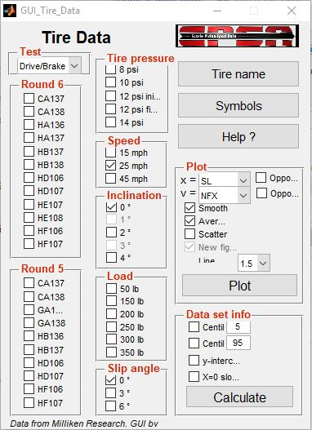

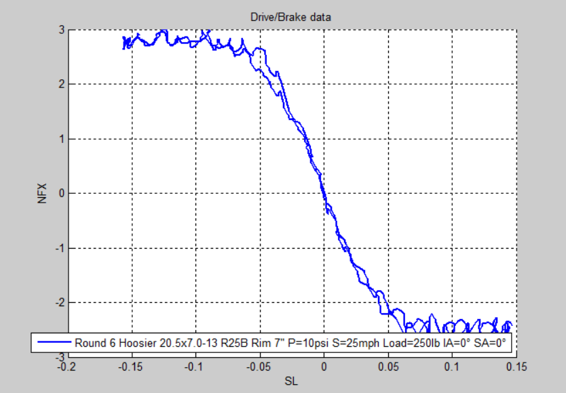

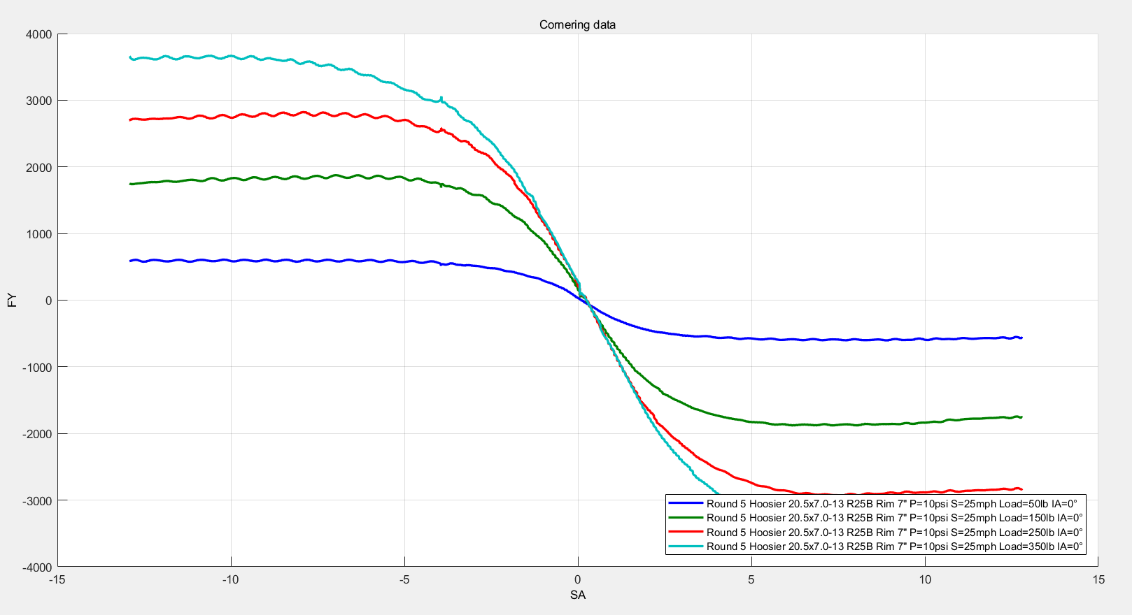

1. **Data treatment with 94” Pacejka formula**

This offers more smooth datas, easier to use:

